**Sakila Database (MySQL)**

Sakila is a sample database developed by MySQL, specifically designed to teach and demonstrate the capabilities of database management systems (DBMS) based on the relational model.

**Sakila DB ER diagram**

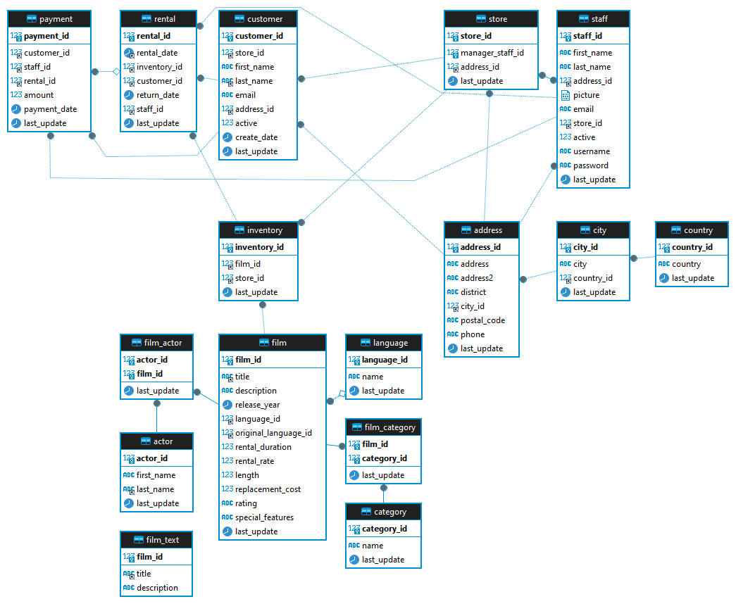

**The Sakila database contains 15 main tables describing various aspects of a DVD rental company.**

**Below is a list of these tables:**

1. actor - table of actors.
2. address - table of customer and staff addresses
3. category - table of films categories.
4. city - table of cities.
5. country - table of countries.
6. customer - table of customers in Sakila database.
7. film - table of films in Sakila database.
8. film_actor - actors to films relation table.
9. film_category - films to categories relation table.
10. inventory - table of items in Sakila database.
11. language - table of films languages.
12. payment - table of customers payments.
13. rental - table of customers rentals.
14. staff - table of company staff.
15. store - table of company stories.

**Table actor**

**Table columns:**

* actor_id - Unique identifier for each actor.
* first_name - First name of the actor.
* last_name - Last name of the actor.
* last_update - When the row was created or most recently updated.

|  |  |  |  |
| --- | --- | --- | --- |
| **actor_id** | **first_name** | **last_name** | **last_update** |
| 1 | John | Doe | 2023-01-01 12:00:00 |

Indexes: PRIMARY KEY, btree (actor_id)

**Table address**

**Table columns:**

* address_id - Unique identifier for each address.
* address - Street address.
* address2 - Additional address.
* district - District or region.
* city_id - Foreign key referencing the city table.
* postal_code - Postal code.
* phone - Phone number.
* last_update - When the row was created or most recently updated.

|  |  |  |  |  |  |  |  |
| --- | --- | --- | --- | --- | --- | --- | --- |
| **address_id** | **address** | **address2** | **district** | **city_id** | **postal_code** | **phone** | **last_update** |
| 1 | 123 Main St | [null] | Downtown | 1 | 12345 | +1234567890 | 2023-01-01 12:00:00 |

Indexes: PRIMARY KEY, btree (address_id)

**Table category**

**Table columns:**

* category_id - Unique identifier for each category.
* name - Name of the category.
* last_update - When the row was created or most recently updated.
* category_id name last_update

|  |  |  |
| --- | --- | --- |
| **category_id** | **name** | **last_update** |
| 1 | Action | 2023-01-01 12:00:00 |

Indexes: PRIMARY KEY, btree (category_id)

**Table city**

**Table columns:**

* city_id - Unique identifier for each city.
* city - City name.
* country_id - Foreign key referencing the country table.
* last_update - When the row was created or most recently updated.

|  |  |  |  |
| --- | --- | --- | --- |
| **city_id** | **city** | **country_id** | **last_update** |
| 1 | Metropolis | 1 | 2023-01-01 12:00:00 |

Indexes: PRIMARY KEY, btree (city_id)

**Table country**

**Table columns:**

* country_id - Unique identifier for each country.
* country - Country name.
* last_update - When the row was created or most recently updated.
* country_id country last_update

|  |  |  |
| --- | --- | --- |
| **country_id** | **country** | **last_update** |
| 1 | United States | 2023-01-01 12:00:00 |

Indexes: PRIMARY KEY, btree (country_id)

**Table customer**

**Table columns:**

* customer_id - Unique identifier for each customer.
* store_id - Foreign key referencing the store table.
* first_name - First name of the customer.
* last_name - Last name of the customer.
* email - Email address of the customer.
* address_id - Foreign key referencing the address table.
* active - Indicates whether the customer is active (0/1).
* create_date - Timestamp indicating when the customer was added to the database.
* last_update - When the row was created or most recently updated.

|  |  |  |  |  |  |  |  |  |
| --- | --- | --- | --- | --- | --- | --- | --- | --- |
| **customer_id** | **store_id** | | **first_name** | | **last_name** | **email** | **address_id** | **active** |
| 1 | 1 | | John | | Doe | john.doe@example.com | 1 | 1 |
| **create_date** | | **last_update** | |
| 2023-01-01 12:00:00 | | 2023-01-01 12:00:00 | |

Indexes: PRIMARY KEY, btree (customer_id)

**Table film**

**Table columns:**

* film_id - Unique identifier for each film.
* title - The title of the film.
* description - A short description or plot summary of the film.
* release_year - The year in which the movie was released.
* language_id - Foreign key referencing the language table; identifies the language of the film.
* original_language_id - A foreign key pointing at the language table; identifies the original language of the film. Used when a film has been dubbed into a new language.
* rental_duration - The length of the rental period, in days.
* rental_rate - The cost to rent the film for the period specified in the rental_duration column.
* length - Duration of the film, in minutes.
* replacement_cost - The amount charged to the customer if the film is not returned or is returned in a damaged state.
* rating - The rating assigned to the film. Can be one of: G, PG, PG-13, R, or NC-17.
* special_features - Lists which common special features are included on the DVD. Can be zero or more of: Trailers, Commentaries, Deleted Scenes, Behind the Scenes.
* last_update - When the row was created or most recently updated.

|  |  |  |  |  |  |  |  |  |  |  |  |
| --- | --- | --- | --- | --- | --- | --- | --- | --- | --- | --- | --- |
| **film_id** | **title** | | **description** | | **release_year** | **language_id** | **original_language_id** | **rental_duration** | **rating** | **special_features** | **last_update** |
| 1 | Film Title | | A brief description of the film. | | 2000 | 1 | 2 | 5 | PG-13 | Trailers, Commentaries | 2023-01-01 12:00:00 |
| **rental_rate** | | **length** | | **replacement_cost** |
| 4.99 | | 120 | | 19.99 |

Indexes: PRIMARY KEY, btree (film_id)

**Table film_actor**

**Table columns:**

* actor_id - Unique identifier for actor.
* film_id - Unique identifier for film.
* last_update - When the row was created or most recently updated.

|  |  |  |
| --- | --- | --- |
| **actor_id** | **film_id** | **last_update** |
| 1 | 1 | 2023-01-01 12:00:00 |

Indexes: PRIMARY KEY, btree (actor_id, film_id)

**Table film_category**

**Table columns:**

* film_id - Unique identifier for each film.
* category_id - Unique identifier for each category.
* last_update - When the row was created or most recently updated.

|  |  |  |
| --- | --- | --- |
| **film_id** | **category_id** | **last_update** |
| 1 | 1 | 2023-01-01 12:00:00 |

Indexes: PRIMARY KEY, btree (film_id, category_id)

**Table inventory**

**Table columns:**

* inventory_id - Unique identifier for each inventory item.
* film_id - Unique identifier for each film in the inventory.
* store_id - Unique identifier for the store where the inventory item is located.
* last_update - When the row was created or most recently updated.

|  |  |  |  |
| --- | --- | --- | --- |
| **inventory_id** | **film_id** | **store_id** | **last_update** |
| 1 | 23 | 2 | 2023-01-01 12:00:00 |

Indexes: PRIMARY KEY, btree (inventory_id)

**Table language**

**Table columns:**

* language_id - Unique identifier for each language.
* name - Language name.
* last_update - When the row was created or most recently updated.

|  |  |  |
| --- | --- | --- |
| **language_id** | **name** | **last_update** |
| 1 | English | 2023-01-01 12:00:00 |

Indexes: PRIMARY KEY, btree (language_id)

**Table payment**

**Table columns:**

* payment_id - Unique identifier for each payment.
* customer_id - Foreign key referencing the customer table.
* staff_id - Foreign key referencing the staff table.
* rental_id - Foreign key referencing the rental table.
* amount - Payment amount.
* payment_date - Date of the payment.
* last_update - When the row was created or most recently updated.

|  |  |  |  |  |  |  |
| --- | --- | --- | --- | --- | --- | --- |
| **payment_id** | **customer_id** | **staff_id** | **rental_id** | **amount** | **payment_date** | **last_update** |
| 1 | 1 | 1 | 1 | 4.99 | 2023-01-01 12:13:14 | 2023-01-01 12:14:15 |

Indexes: PRIMARY KEY, btree (payment_id)

**Table rental**

**Table columns:**

* rental_id - Unique identifier for each rental.
* rental_date - Date when the rental occurred.
* inventory_id - Foreign key referencing the inventory table.
* customer_id - Foreign key referencing the customer table.
* return_date - Date when the rental was returned.
* staff_id - Foreign key referencing the staff table.

|  |  |  |  |  |  |  |
| --- | --- | --- | --- | --- | --- | --- |
| **rental_id** | **rental_date** | **inventory_id** | **customer_id** | **return_date** | **staff_id** | **last_update** |
| 1 | 2023-01-01 16:15:21 | 1 | 1 | 2023-01-10 09:12:36 | 1 | 2023-01-01 12:00:00 |

Indexes: PRIMARY KEY, btree (rental_id)

**Table staff**

**Table columns:**

* staff_id - Unique identifier for each staff member.
* first_name - First name of the staff member.
* last_name - Last name of the staff member.
* address_id - Foreign key referencing the address table.
* picture - Staff member picture.
* email - Email address of the staff member.
* store_id - Foreign key referencing the store table.
* active - Indicates whether the staff member is active (0/1).
* username - Username for login.
* password - Password for login.
* last_update - When the row was created or most recently updated.

|  |  |  |  |  |  |  |  |  |  |  |
| --- | --- | --- | --- | --- | --- | --- | --- | --- | --- | --- |
| **staff_id** | **first_name** | | **last_name** | **address_id** | **picture** | **email** | **store_id** | **active** | **username** | **last_update** |
| 1 | John | | Doe | 1 | [null] | john.doe@example.com | 1 | 1 | johndoe | 2023-01-01 12:00:00 |
| **password** | |
| ******** | |

Indexes: PRIMARY KEY, btree (staff_id)

**Table store**

**Table columns:**

* store_id - Unique identifier for each store.
* manager_staff_id - Foreign key referencing the staff table for the store manager.
* address_id - Foreign key referencing the address table.
* last_update - When the row was created or most recently updated.

|  |  |  |  |
| --- | --- | --- | --- |
| **store_id** | **manager_staff_id** | **address_id** | **last_update** |
| 1 | 1 | 1 | 2023-01-01 12:00:00 |

Indexes: PRIMARY KEY, btree (store_id)